Add/Edit a User Role

**Story:** As an Administrator, I want to add/edit a User Role to manage roles in Diamond system.

**Pre-Conditions:**

* Administrator arrived to the window form by following Menu and Submenu and initialize Add function;
* Or Administrator selected one User Role from the list and initialize Edit function.

Initialize Add function

Fill User Role Name

Assign Tasks

Submit information

Select User Role & Initialize Edit

**Workflow:**

**Scenario:**

1. Administrator initializes Add function Or initializes Edit function after selecting a User Role
2. Administrator fills in User Role Name
3. Administrator assigns a set of Assigned Tasks from Available Tasks
4. Administrator submits information
   1. If User Role Name is empty, an alert message will appear
   2. If User Role Name is not unique, an alert message will appear

**Storyboard Images:**

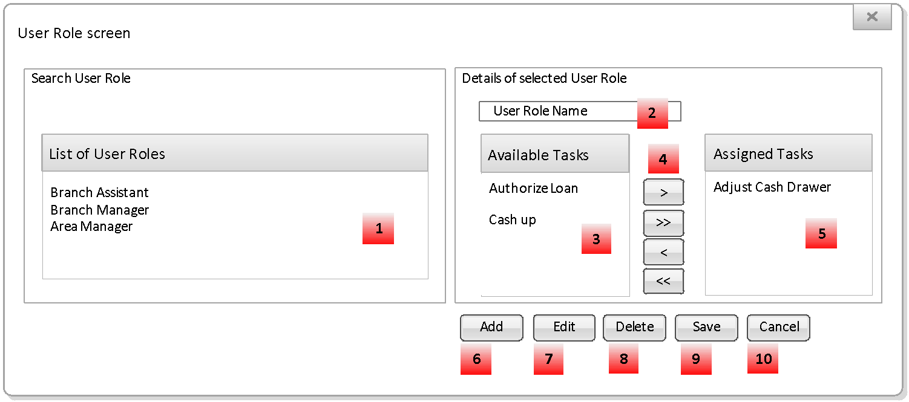

Add User Role Name



**Requirements:**

|  |  |  |
| --- | --- | --- |
| **Image Reference** | **Requirement** | **Step in Scenario** |
| 3 | Tasks are predefined data items. It does not need a form for management. A task will be associated with granted activities/transactions |  |
| 2 | User Role Name:  Unique and required |  |
|  | “Available…” and “Assigned…” are not overlap. When combine them we have full list of Tasks |  |
|  | NFR027-NFR035 – Reference to GUI transformation |  |
| 9 | When Administrator clicks Save |  |
|  | “User Role Name should be unique.” [OK] | 4b |
|  | List of Tasks:   |  | | --- | | Access Admin Functions  View Branch Details  Add/Edit/Delete Branch details  View Broker Details  Add/Edit/Delete Broker details  View Company Structure  Add/Edit/Delete Company Structure  Add/Edit/Delete Users  Add/Edit/delete Global IP's  Add/Edit/Delete user Roles  Add/Edit/Delete Lookup fields  Add/Edit/Delete main Office Set up  View Main Office Set up  Add/Edit /Delete Supplier contacts  View Products  Add/Edit/Delete Products (This would be Product Types and Product Groups)  View Parameters  Add/Edit/Delete Parameters  Delete/Merge Customers  Add/Edit/Delete/Import Bank SortCodes  Add/Edit/Delete/import FX Rates  Add/Edit/Delete TimePeriods  Add/Edit/Delete Non Revenue Generating Transaction  Confirm Days Cashing up  Add/Edit/Delete Accounting Matrices | |  |

**Post-Conditions:**

* A User Role is added/edited.

**Acceptance Criteria**

|  |  |
| --- | --- |
| **Test** | **Expected Result** |
| Test to determine the alert message appears when User Role Name is empty | After click Save, there is appropriate alert message  Please input User Role Name |
| Test to determine the alert message appears when User Role Name is not unique | After click Save, there is appropriate alert message |
| Test to determine the alert message appears when edited successfully | After click Save, there is appropriate alert message  <User Role Name> is updated successfully. |
| Test to determine the alert message appears when added successfully | After click Save, there is appropriate alert message  <User Role Name> is added successfully. |
| Test to determine the User Role added successfully | User Role is added, search results are cleared |
| Test to determine the User Role edited successfully | User Role is edited, User Role is selected (if the paging is not changed) |
| Test to determine the User Role edited/added unsuccessfully | Stay in the same status |
| Test to determine action Cancelled | Back to Requirement before Step 1 of Scenario |